# MetaData And Schemas

**Group Members:**

1. **Devanand P. Mundhe**
2. **Amit V. Deshmukh**
3. **Jayraj Solanki**

* Propagating schema changes
* Creating a generic schema from existing metadata
* Cutting and pasting schema information

Introduction

Managing metadata is one of the most important aspects of developing Talend jobs, and the most common form of metadata used within Talend jobs is the schema.

1.Propagating schema changes

* **How to do it…**
* Open the Talend Job CostumerDetails_propagateSchema so that the right-hand palette becomes available. Then, from the metadata palette, open the Generic schema CostumerDetails_genericCustomer.
* Add a new field **emailAddress**, as shown in the following screenshot:

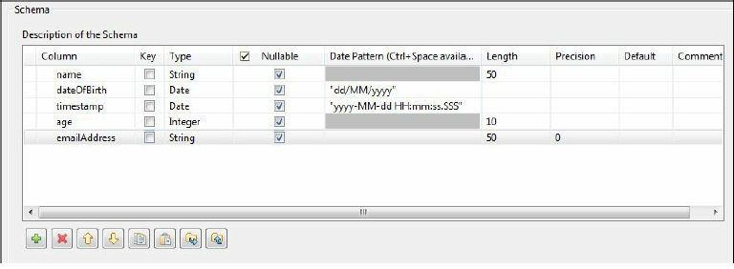

* Click**Finish** to save the change to the schema. Then, click **Yes** to apply the changes to all jobs when prompted.

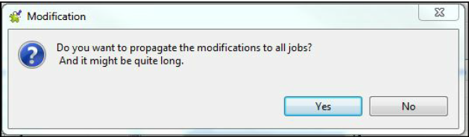

* Click**OK** to accept the changes in the next dialogue box. You will now see that the job has an error in the output.

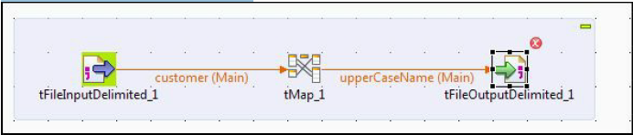

* Open the tFileOutputDelimited, and click the **Edit Schema** button to open the schema and select the **View Schema** option.
* As you can see in the following screenshot, the table on the left-hand side is different from that on the right-hand side. Click the https://mindmajix.com/blogs/images/Screenshot_47(6).png to copy the right hand schema into the left-hand panel.

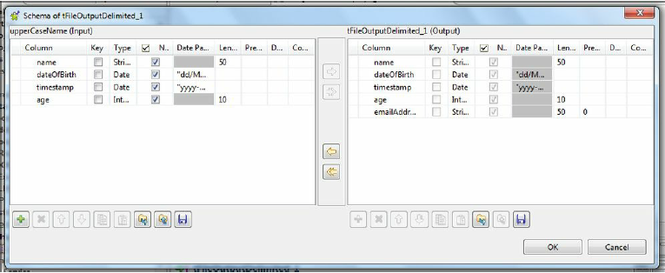

* Click **OK** to save the changes.

2.Creating a generic schema from existing metadata.

Any schema can be easily converted into a generic schema to enable it re-used.  
Generic schemas aren’t tied to a particular source, so they can be used as a shared resource across multiple types of data source or they can be used to define data sources that are generated, such as the output from custom SQL queries.

**How to do it…**

From repository schema

* Open repository schema fd_cook_0020_customerDelimited that can be found in the delimited schemas, ensuring that you click the**metadata**, rather than the parent schema.

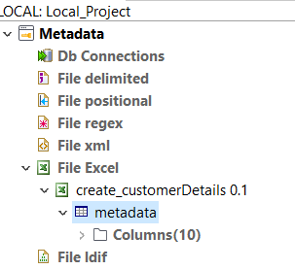

* Right-click **metadata,** and then select **copy to Generic schema.** This creates a schema Create_customerDetails.
* Move the new schema to the **generic Scehma and**  double click it to edit it.
* Change the name to Create_customerDetails.

3.Cutting and pasting schema information.

This technique is a real time saver, but isn’t always immediately obvious, because the schema dialogue does not contain a right-click option.

**How to do it…**

Make a copy of the job CostumerDetails_builtInSchema, rename it to **costumerDetails_copySchema**, and open the new job.

 Drag a **tFileOutputExcel**component from the right-hand palette.

Open**tFileOutputDelimited,**and then open the schema.

Click the left-hand panel and press Ctrl+A to select all the columns.

Press Ctrl+C to copy the highlighted columns.

Open the **tFileOutputExcel**component, and then open the schema. It should be blank.

Press CTRL+V to paste the columns.

**How it works…**

Press CTRL+V to paste the columns. Talend allows the standard windows shortcut keys to be used to cut and paste column information between schemas.  
You can also use Ctrl+left mouse button to highlight individual columns and Shift+left mouse button to highlight a range as per the usual Windows conventions.